**Report of AB Test of First Month Free for Paid Plan Campaign**

1. **Introduction**

The company offer a product with a set of two type of plan. The first is the lower feature with free to use plan, while the second is the paid plan started at USD 20/month. To increase the conversion of customer buying the paid plan, a set of experiment is conducted.

The experiment has done by randomly set the customer into two groups – control and treatment. The treatment group is the customers which was given the experience of paid plan feature through “first month free” campaign. While on the other hand, the control group is the customer who just get the limited feature free plan. The experiment is conducted for desktop and mobile user across time zone.

The purpose of this experiment is to answer the following questions:

* Whether the campaign made for Paid Plan product has significant impact to the costumer’s conversion of buying the Paid Plan.
* Whether the campaign has impact on the amount of time the customer spends before purchasing the Paid Plan.
* Whether the campaign can be implemented in smaller set of the group
* Whether the campaign is profitable enough to be implemented for longer time.

1. **Body**
   1. **Data**

The data collection is started from 1st June 2022 until 31st July 2022. The data consists of 30000 rows with each row is a unique user. The data consists of 7 columns – ***id_user, experiment_date, treatment, platform, time_zone, cancelled_paid_plan_or_not, paid_plan_signup_date***.

* 1. **Methods**

To gain insight from the data, the following step of analysis is conducted:

* + 1. Creating the columns to differentiate whether a user signup for paid plan or not.
    2. Splitting the data into control and treatment set.
    3. Performing normality test to determine what type of AB Test Method should be done.
    4. Performing AB test for signup.
    5. Performing AB test for time of customer purchasing the paid plan.
    6. Performing AB test for customer who cancel the paid plan.
  1. **Analysis**

The analysis process was done by assigning the label for user who sign up and user who did not sign up. This process is done mapping the ***paid_plan_signup_date*** columns. User who has this columns value as NaN will be labelled as 0 and user who get this columns value as date will be labelled as 1. The comparison between treatment groups for sign up rate is shown in the following bar plot.

According to the bar plot, it is indicated that the treatment group has more conversion of user into purchasing paid plan. To get a strong basis for stating the claim, a different of group mean is conducted. By measuring the normality of the dataset, it is known that the data is not normally distributed. A non-parametric approach for group means difference need to be done. A Mann-Whitney-U test is conducted.

Hypotheses for this test is stated bellow:

* H0 = The treatment group mean for paid plan sign up rate is less than the control group
* H1 = The treatment group mean for paid plan sign up rate is greater than the control group

According to the test result, the p_value for this test is $3.347* {10}^{-7}$, which is lower than the significance level. Which indicated that the paid plan signs up rate of treatment group is significantly greater than the control group.

Another interesting insight that needs to be researched further is the fact that most of the user who sign up for paid plan is using desktop like showed in this following bar plot.

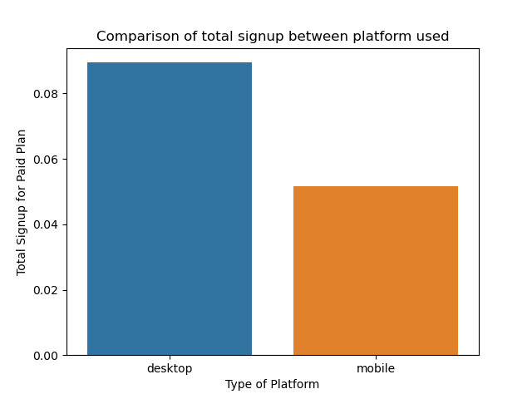

Also, there are quite huge gap between user who signs up for paid plan with specific time zone.

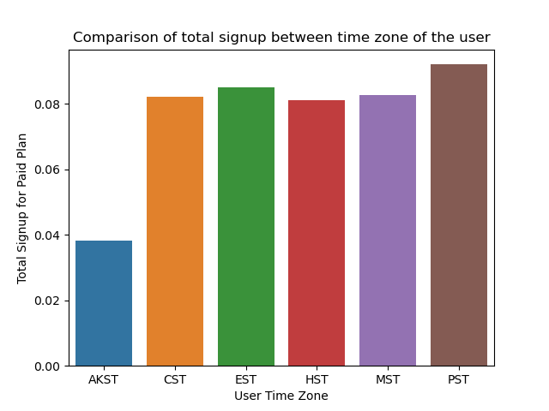

A same testing method is done for the time delta of user who signs up for paid plan. A new set of hypotheses is stated bellow:

* H0 = The time delta of paid plan signs up for group mean for paid plan sign up rate is significantly less than the treatment group.
* H1 = The time delta of paid plan signs up for control group is significantly greater than the treatment group

As expected, that the time delta for control group to sign up for paid plan is greater than the treatment group. It is stated from the p_value of this test is 0.99 which results in rejection of H0. It means that the campaign makes the user purchase the paid plan faster compared to the user who is not exposed with the campaign.

In terms of user who cancelled the paid plan, the same test has been conducted with the set of hypotheses stated bellow:

* H0 = The user who cancelled paid plan from control group is significantly less than the treatment group.
* H1 = The user who cancelled paid plan from control group is significantly greater than the treatment group.

As the p-value of this following test is 0.59, which rejected the null hypothesis. It can be said that the cancel rate for control group is greater. However, the difference is not quite big, since the bar plot which compared the cancel rate of the two groups has no difference in height. The bar plot is shown below.

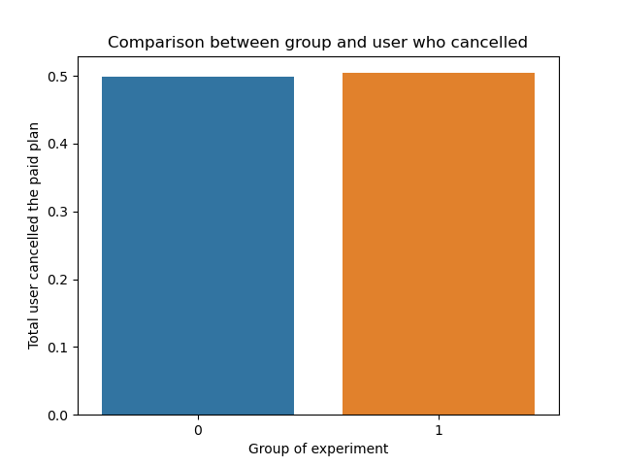

This result shows that, even though the campaign can make the user who purchasing the paid plan more and faster than the control group. The cancel rate is still quite high, which means it will hard achieve break even for just implementing this campaign. As the desktop user tends to purchase the paid plan, it will be good idea for optimizing this campaign to this user type. Moreover, the total of purchased paid plan is differ in different time zone. It will also be good idea to set different campaign for user in AKST time zone.

1. **Conclusion**

From the analysis done in this test, several conclusions can be made.

1. The campaign impacts the paid plan purchase significantly great, by increasing the amount of user who purchase paid plan.
2. The campaign also makes the user spends fewer time before purchasing the paid plan.
3. The campaign can be optimized for user with desktop platform since this user type purchases the purchase the paid plan more than the mobile user.
4. Another campaign can be implemented for user in AKST time zone, since the user who purchase the paid plan of this time zone is the last compared to other time zone.
5. Even though the Mann-Whitney-U test stated that the treatment group has less user who cancel the paid plan, the bar plot indicated that the different between treatment and control group is not much. So, utilizing this campaign alone will make the break-even hard to achieve.
6. **Recommendation**

From this following set of tests, it is indicated that the campaign has positive impact in conversion of user to purchase the paid plan. However the campaign has great impact for desktop user only, another set of campaign can be implemented for mobile user. A specific campaign for different time zone can also be implemented since there is time zone which has less user to purchase the paid plan.